Product Overview
Daytime Visibility Range: 1000m ~ 5000m
Nighttime Visibility Range: 500m ~ 1000m
Detection Range: 150m ~ 5000m
Product Features: High Speed & Agile, Artificial Intelligence, No Blind Spots, Dual-Spectrum
Application Areas: Vehicle Patrol, Safety Production, Urban Surveillance, Power Energy, Roads & Bridges, Forest Fire Prevention, Ecological Protection, Water Conservancy & Lakes, Ports & Docks, Barracks, Bases, etc.

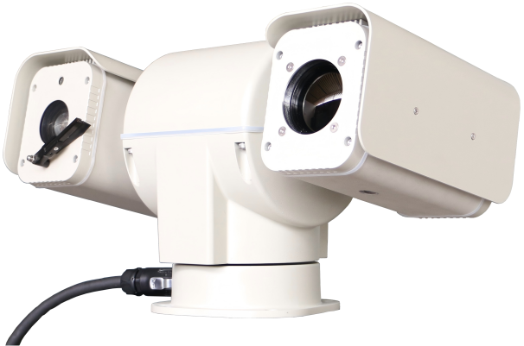

Features
- Dual-Spectrum: Combines thermal imaging and high-definition visible light for complementary detection, enabling round-the-clock, wide-area rapid search and close-range clear target observation
- Equipped with electronic and optical defogging, unaffected by sandstorms, fog, rain, snow, etc
- Visible light camera features image enhancement, starlight technology, supports image stabilization, heat haze suppression, stable image under vibration, clear image under intense sun, no crawling texture
- Thermal imager features image detail enhancement, black-hot/white-hot polarity switching, multiple pseudo-color palettes
- Supports absolute positioning, relative positioning, and GPS coordinate positioning; compatible with radar and other detection devices, reducing system debugging time
- During radar linkage, there is no autofocus process, allowing the target image to appear clear immediately, facilitating target tracking
- Predictive PID algorithm for moving targets, seamless integration with radar tracking, solves the problem of tracking targets in radar blind spots
- Actively uploads azimuth angle, field of view, focal length value, and focus value
- Supports stepless speed control, speed resolution 0.01°
- Continuous 360° horizontal rotation, -90° to +90° vertical tilt, completely eliminating blind spots
- Ultra-quiet PTZ drive technology, suitable for noise-sensitive areas
- Surge and lightning protection, effective protection range 2500VA
- Intelligent Temperature Control: Variable power heater, ultra-low temperature startup, automatic cooling fan
- IP67 protection rating
- Small integrated design, total unit weight 8 kg
Product Description
The AK-LF2000 Series Dual-Spectrum Integrated PTZ Camera is a high-performance camera specifically designed and developed for special applications, heat source monitoring, and long-range day/night surveillance.
The product is based on the latest opto-mechatronic integration technologies: 6th generation uncooled infrared imaging technology, high-definition visible light imaging technology, high-speed precision small gimbal technology, edge computing (AI front-end) technology, and high-level field protection technology. This enables the device to "see far," "see clearly," and "understand what it sees" even in harsh outdoor environments.
The thermal imager uses a high-sensitivity, ultra-high resolution uncooled detector, an athermalized compact infrared lens, and advanced image processing algorithms to provide smooth, detailed images. The visible light camera uses an integrated full-HD color/black-and-white dual-mode low-illumination core. The overall unit is small and lightweight, bringing great convenience to user installation and application. It is complemented by a 360° omnidirectional no-blind-spot high-speed PTZ, enabling target search over distances up to 5km. An embedded industrial-grade control system achieves highly stable control of the camera's zoom, focus, mode switching, and PTZ tilt/pan movements.
The AK-LF2000 series housing is made of high-strength aluminum alloy, featuring a robust and fully sealed structure, achieving an IP67 protection rating. The surface is coated for oxidation resistance and anti-salt fog protection, ensuring long-term stable operation in harsh outdoor environments.

Technical Specifications
Range Indicators
Range against a person | Visible Light: Detection 2000m, Recognition 1000m, Identification 500m  Thermal Imaging: Detection 1000m, Recognition 500m, Identification 300m
Range against a drone | Visible Light: Detection 1200m, Recognition 600m, Identification 300m  Thermal Imaging: Detection 600m, Recognition 300m, Identification 150m
Thermal Imaging Specifications
Detector | 6th Gen Uncooled Detector, Wavelength 7-14μm, Array 640×512
NETD | <35mK (@25°C F1.0)
Lens | Fixed focal length, F1.2, 50mm
Lens Control | Manual focus / Auto-focus (selectable)
Image Processing | 16 pseudo-color images, Black-hot/White-hot polarity switching, Uniformity correction
Burn Protection | Supports anti-sun burn protection
Temperature Measurement | Supports multi-point temperature display, threshold setting, and alarm function
Visible Light Specifications
Image Sensor | 1/1.8" Low Illumination CMOS
Pixels | 4 million
Lens | 6.5mm ~ 240mm
Minimum Illumination | Color 0.01Lux (F1.5), Black/White 0.001Lux (F1.5)
Defog | Electronic + Optical Dual Defog
Image Stabilization | Supports gyroscope-based electronic stabilization, heat haze suppression
Image Processing | Supports 3D intelligent noise reduction, highlight suppression, wide dynamic range, frame accumulation, backlight compensation
Operation Specifications
Pan/Tilt Speed | Control Speed: 0.01°/sec to 60°/sec, Preset Speed: 100°/sec
Speed Levels | 64 levels, supports stepless speed control (10000 levels)
Rotation Range | Horizontal 360° continuous rotation, Vertical +90° to -90°
Presets | 255 preset positions (expandable to 10000), power-off memory, not lost or deviated after power-off
Precision | ±0.1°
Positioning Function | Supports absolute positioning, relative positioning, and GPS information positioning
3D Positioning | Supports box selection, zooming, and positioning
Data Feedback | Query/Active upload of azimuth angle, field of view, focal length value, focus value
Integration Methods | Transparent channel, SDK protocol, private protocol, National Standard GB28181, ONVIF, compatible with mainstream border/coastal defense platform software
Interface Specifications
Network Interface | 1 x 100M Ethernet port
Serial Interface | 1 x RS422 interface
Power Interface | DC24V, Max power consumption 45W, Power consumption without heater 15W
Environmental Specifications
Manual Defog/Defrost | On/Off
Operating Temperature | -40°C ~ 70°C
Storage Temperature | -60°C ~ 90°C
External Environment | Humidity ≤95% RH (non-condensing), operable at altitudes up to 3500m
Temperature Control System | Intelligent temperature control, variable power heater, ultra-low temperature startup, automatic cooling fan
Wind Resistance | Normal operation at wind speeds up to 150 km/h, withstands maximum wind speeds up to 210 km/h
Lightning & Surge Protection | Power interface 6000V, Signal interface 4500V
Protection Rating | IP67
Airtightness | Maintains pressure for extended period after filling with high-pressure gas
Dimensions | 426mm × 210mm × 236mm (L × W × H)
Weight | Net weight 8KG

Product Dimension Drawing
